Feasibility Algorithm Performance

Tau -> | 0 | 1 | 2 | 3 | 4 | 5 | 6 | 7 | 8
Function 1 | 5 | 8 | 10 | 15 | 15 | 16 | 18 | 20 | 22
Function 2 | 6 | 9 | 11 | 13 | 13 | 12 | 11 | 10 | 8
Function 3 | 4 | 7 | 9 | 14 | 20 | 19 | 19 | 18 | 18
Function 4 | 6 | 6 | 4 | 7 | 8 | 12 | 14 | 22 | 34

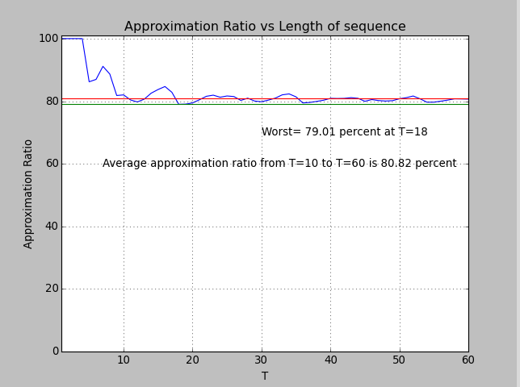

Tau -> | 0 | 1 | 2 | 3 | 4 | 5 | 6 | 7
Function 1 | 3 | 5 | 8 | 10 | 12 | 14 | 11 | 8
Function 2 | 5 | 5 | 7 | 10 | 15 | 14 | 9 | 7
Function 3 | 8 | 7 | 3 | 1 | 12 | 15 | 20 | 24
Function 4 | 3 | 4 | 7 | 10 | 12 | 23 | 24 | 2
Function 5 | 4 | 6 | 8 | 15 | 17 | 10 | 8 | 8
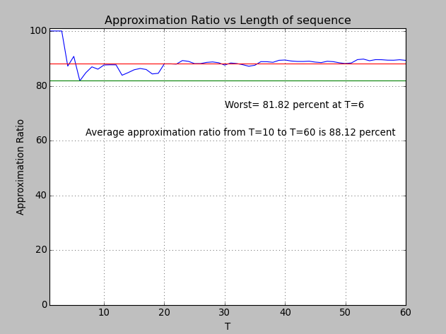

Function 1:
3 15 24 28 50 78 83 99 126 143 152 152 164 169 180 190 214 226 253 260 276 285 296 311 328 348 370 377 387 398 428 444 462 491 514 521 542 571 587 591
Function 2:
37 58 73 99 118 144 150 173 191 206 221 237 265 271 300 313 323 343 366 383 412 429 450 454 480 499 495 487 484 477 469 467 460 454 448 442 433 424 415 415
Function 3:
27 23 13 8 0 0 7 15 32 41 63 93 122 149 157 162 189 213 213 237 249 269 279 283 307 329 331 336 343 373 384 394 415 444 454 478 482 483 483 505
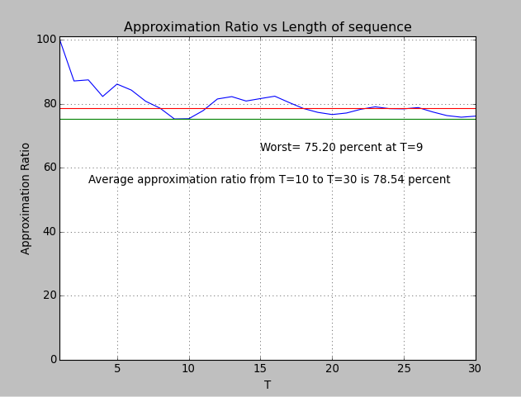

Function 1:
12 15 20 21 21 26 35 40 41 35 31 25
Function 2:
15 15 14 13 10 20 24 51 53 55 55 60
Function 3:
16 19 24 24 29 32 38 40 45 46 59 67
Function 4:
12 12 11 11 10 10 30 34 76 81 82 82
Function 5:
23 24 24 25 25 26 30 30 34 28 23 12

